**2021 FAWCO Friendship Quilt instructions**

Dear FAWCO Quilters,

Thanks for participating in another successful project! At last count, the 2020 Friendship Quilt raised about $3500 in spite of social isolation issues. I hope you’re all staying safe at home, in good health and spirits. Quilting always cheers me up, so maybe you’d like to get started on next year’s quilt.

I love piecing circles and making quilts with circles. It’s such a satisfying shape. But apparently lots of quilters are terrified by the idea and never give it a try. Fear not! You may choose between two ways of achieving this block, which is 6.5” unfinished size:

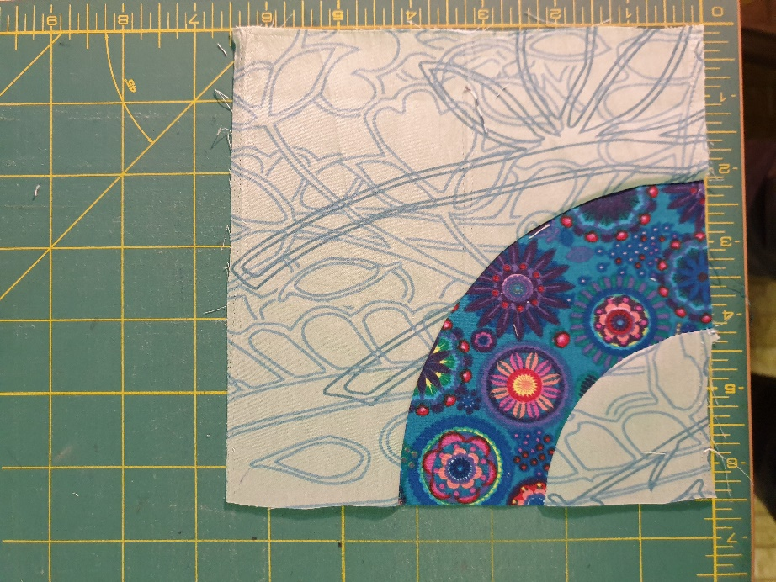

Colors: pick any you like, as long as it’s 100% cotton. You need a good contrast between light and dark. It’s also ok to make a dark background and a light quarter-circle.

**Method #1: Traditional Piecing**

Cut out the 3 pieces at the end of this document (1/4 inch seam allowances included) and use them to cut your fabric. Be as accurate as you possibly can. **(Note: this document should print to actual size. The long edges of the big background piece should measure 6.5”. Check before you continue!)**

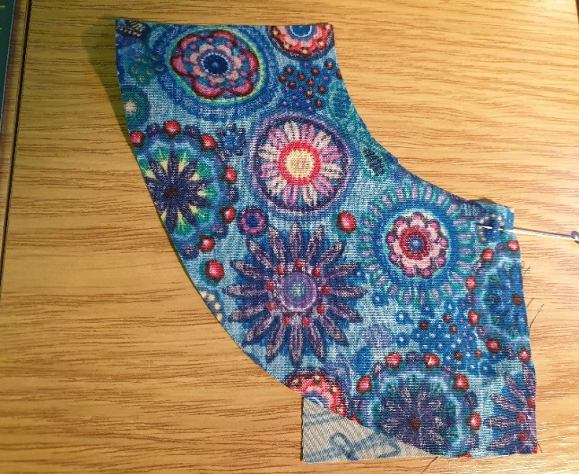

Next, lay the concave arc on top of the little quarter-circle as shown. The 90° corner is at bottom right. The straight edges of both pieces are aligned, and the seam allowances will line up for about the first quarter inch before curving off in opposite directions. “Baste” this bit of the seam along the stitching line, using a fine straight pin to take 2-3 “stitches”.

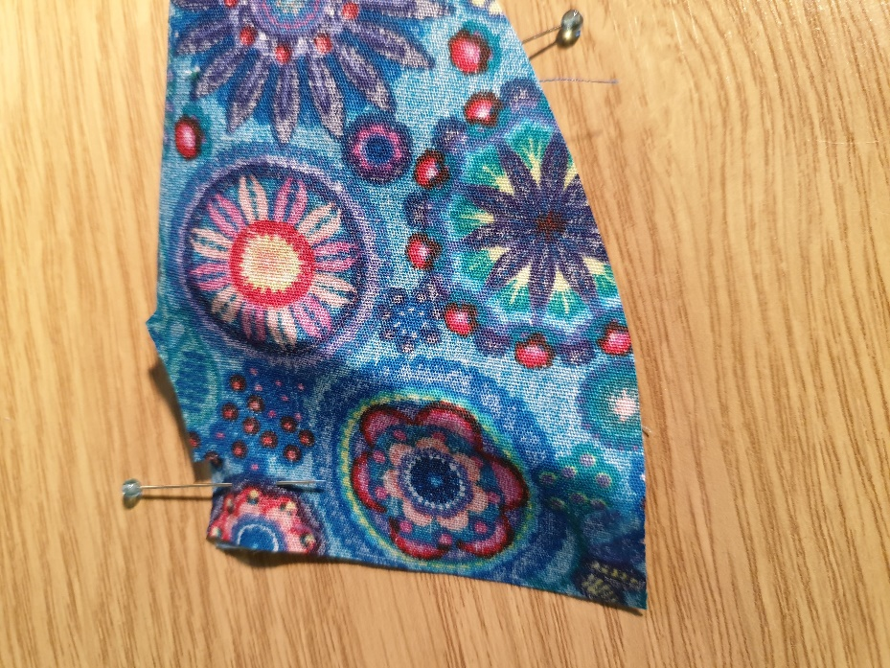

Bring the other end of the arc around so the other straight edges are aligned. Place a pin somewhere near the beginning of the seam, just to hold it and give yourself a little handle.

Start stitching. Stop after 3-4 stitches and remove the pin. (Sewing over pins is a cardinal sin. Don’t get me started.)

This is when I remind you of the Very Important Quarter-inch Seam!!!!

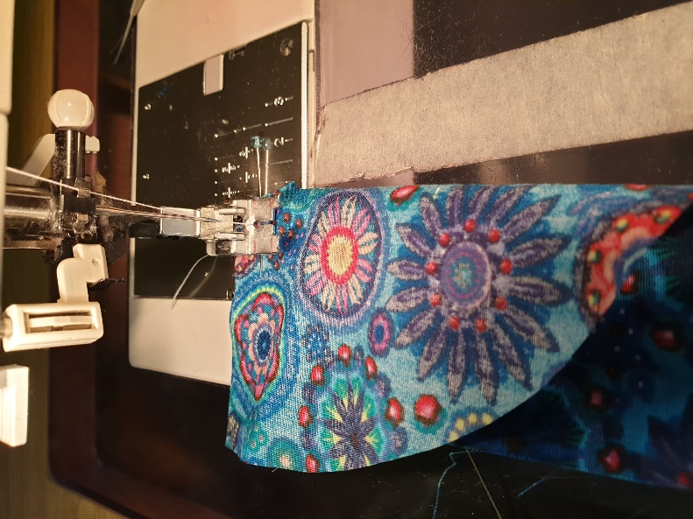You will note that these pieces don’t make a straight line (duh! Making circles!), and the end of the arc wants to fold under. Don’t worry.

Now smooth out the little quarter-circle and nudge the seam edge of the arc until the edges line up, curving around to your left. You can place a few pins to hold this position (I usually don’t bother), and there’s a halfway mark on the pattern pieces for those who find it useful. You might also need to notch the concave edge. The two pieces have seam allowances of exactly the same length, it’s just the curved edges that are different.

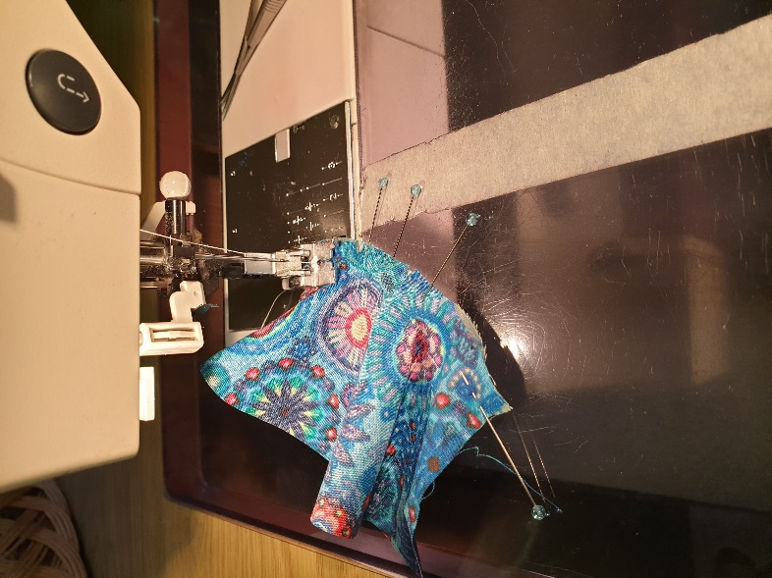 Keep stitching around the curve (removing those pins) until you get to the tip of the last, basting, pin. You might need to stretch the pieces a bit to avoid tucks. Take your time.

Hold on to the head of that pin as you stitch, and let the machine pull the fabric off.

Press toward the quarter circle. Here it is from the back. Notice that the straight edges line up.

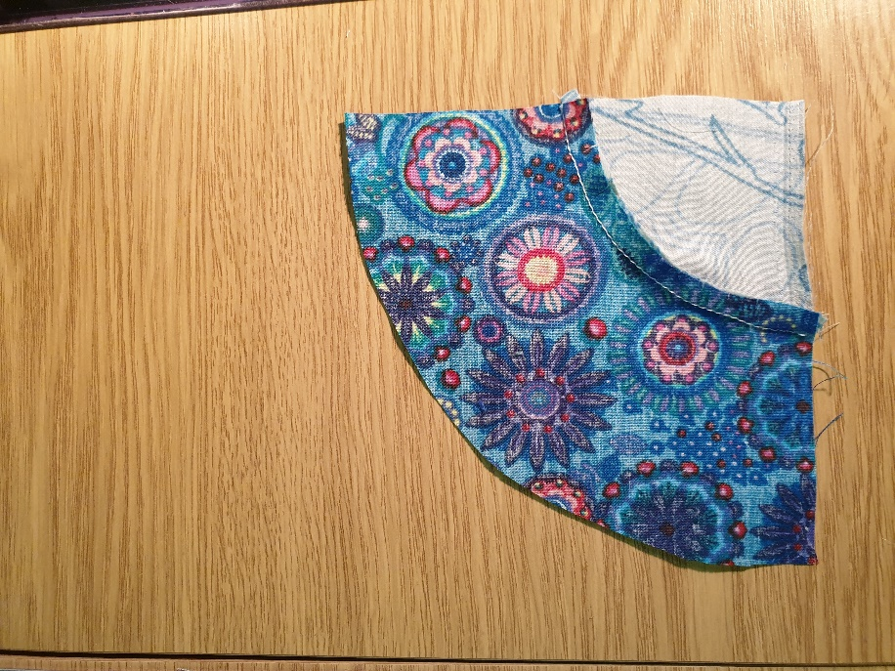Use this piece as the new quarter-circle and add the rest of the background the same way.

**Method 2: Appliqué**

Lots of ways to do this. Use whatever method you prefer (fusible, raw edge, needle turn...) Start by cutting a 7” square of your background. Use the arc piece with no seam allowance to cut the arc (adding a narrow seam if you do needle turn) and appliqué in place. You may send it to me and I will trim to 6.5”

**Deadline: October 1, 2020**

Questions? [rl.zollner@gmx.net](mailto:rl.zollner@gmx.net)

