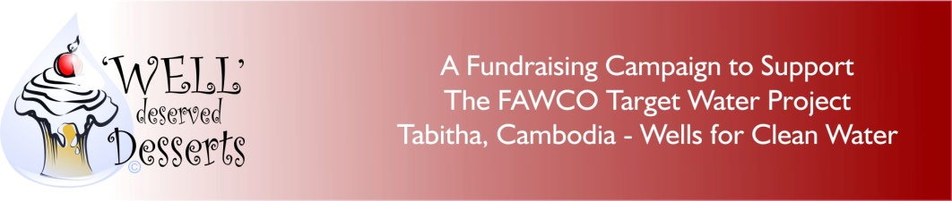

DONATION FORM

If you wish to make a donation to the FAWCO Target Water Project, please read!

Individual donations can be made directly to The FAWCO Foundation. Indicate the name of your club. Your name will appear under their club’s name in all acknowledgements. These individual donations are US tax deductible to the fullest extent provided by law. Once your donation has been received, a receipt and thank you will be sent to you.

Your Name__________________________
Email address: _____________________
Your Postal address_____________________
_____________________________________

Your Club’s Name:___________________________

Amount of Donation (please list currency) __________________
Date of Donation___________________________________

Method of Donation:

_________Wire Transfer: To send a donation via wire transfer please contact treasurer@fawcofoundation.org for transfer details

_________PayPal: To make a donation with a credit card, please go to: https://www.paypal.com/us/cgi-bin/webscr?cmd=_flow&SESSION=iGlPLLA8syJwxAjGtoZHXNtf2AaPhZ3_vwbpK4ZSgvF5Mobsi3JK3AUZ45W&dispatch=5885d80a13c0db1f8e263663d3faee8d422be6d275c375afb284863ba74d6cdc

(If you are receiving this form in hard paper copy - please go to www.fawcofoundation.org then click on donations- the right side bar has a PayPal button that will directly link you to the FAWCO Target Water project donation)

_________US Check: Please make payable to The FAWCO Foundation and send to:
Liz Hemminger
137 Clarewill Avenue
Upper Montclair, NJ 07043 USA

