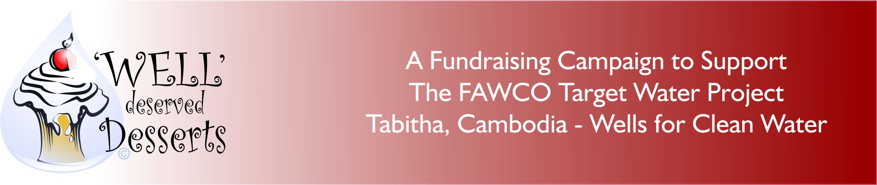

Recipe for Success Number 3

CHOCOLATE-

Need We Say More?

Let’s face it! ANY Event is better with chocolate-a party, a dinner, a class, (a bath!) Here’s a chocolate event with a “blast from the past”.

Our first idea is a time tested winner with a vintage twist. Back in the day “fondue parties’ were all the rage. Appetizers and main course items dipped in cheese or oil and dessert was a luscious creamy chocolate sauce heated in a pot warmed by Sterno. Bananas, strawberries, biscuits you name it, we dipped it. Why not bring that back with a “70’s (or 80’s) Styled Fondue Party”?

Now we know what you’re thinking, who has a fondue pot these days? To be honest, LOTS of us! Put the call out to your members. You may want to consider getting a local caterer or chocolate shop to donate a chocolate fountain. These have become popular everywhere.

Next, get out those old photos of you (or your parents) from the days of disco. Invite everyone to dress up in their John Travolta “Fever” gear-or, and (we know some of you have them) that dress with the BIG shoulder pads. Speaking of big, don’t forget the hair! For the guys, fashion a Fu Manchu mustache or those mutton chop sideburns (costume shops can help) and get ready to have a BIG night.

Set the event with tasting stations, each with a different theme using many different “dipping” items. Is there some local specialty that you thought would taste great smothered in chocolate? Now’s the time to try it. Offer prizes for the most unusual “dipping item” or the best costume. And, if space and time permits, download some Bee Gees or Donna Summer on an iPod, install the disco ball and dance off some of the chocolate! How about a prize for that?

How do we make money on this event?
- Charge admission
- Raffle gift certificates for a fondue pot, or something from a chocolate shop or supplier.
- Sponsorship for the event from local kitchen shops, chocolate shops or tea rooms
- Hold an auction at the event for something vintage or something chocolate
- Donations from participants. Be sure to have the FAWCO Target Water Project Brochure and form on hand.
- Consider including the donation form with the publicity in your newsletter about this event. You might receive donations from those not able to attend.

Some of the things to consider when organizing this event:
- The venue-all important! A kitchen is required; the event will need to be held at your clubhouse, local school or at a member’s home. If you are using Sterno pots, be aware of safety standards.
- Chocolate loving volunteers for your committee. If they enjoy cooking, ask them to help prepare for this event. If they have to purchase any items for the evening for a donation or “best price” and in return be sure to acknowledge it on the night or as your club deems appropriate.
- Brochette sticks for dipping, lots of napkins are a must.
- Volunteers to decorate the venue in “the period.” This will get everyone in the mood. Music is great, or perhaps run an old movie or TV show (silently) in the background.
The FAWCO Foundation has developed some tools to assist you with organizing this project. We have developed a brochure that can be used as a handout at any event that includes information about the Target Program and the Tabitha-Cambodia Wells for Clean Water Project. We also expanded that brochure to include information about Fondue Party event and a solicitation letter for prospective business sponsors and donors. There is a freestanding solicitation letter and sponsor’s thank you letter. These may be customized to suit your needs.

To publicize the event in your newsletter or on your website we have written a press release. You may wish to download the FAWCO Target Water project power presentation to show at your board or club meetings or at the event. We have included the “Well” Deserved Desserts logo and the Target Program logo on jpegs.
The FAWCO Foundation is providing a “Sous Chef” a volunteer who will try to answer any questions you might have about organizing this event:

Please note that these documents are in Word format so that you can customize them however you wish. If you are including other activities in the event, include them and if you are not able to include all of the ones suggested, remove them.
HAVE A GREAT EVENT !

FOR THIS EVENT, THE FOLLOWING SUPPORTING DOCUMENTS CAN BE FOUND AT: http://fawcofoundation.org/index.php?option=com_content&view=article&id=172&Itemid=140
- The FAWCO Target Water Project Tabitha, Cambodia Wells For Clean Water brochure
- The same brochure with a solicitation form letter attached
- Thank you note for sponsors, and others who helped make event a success
- Sample press release for this event at your club
- Donation form
- Recipe for the Fondue sauce
- Link to Wells for Clean Water presentation
- “Well” Deserved Desserts and Target Logos

