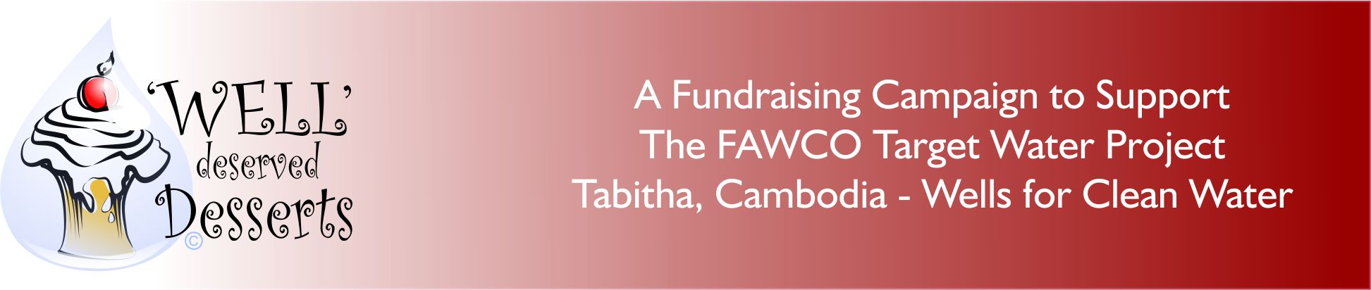

Recipe for Success Number 2

“Heavenly but Healthy”-

A Dessert Event You Can Actually Live By!

This fundraising event will prove that living a healthy lifestyle doesn’t mean you are condemned to a life of rabbit food!

This event is very flexible! You can include whatever you want to make it a fun, fit and informative. It is a bit specialized. Some of the activities you might want for this event:
- A demonstration cooking class. Select one or two of the recipes. Have them prepared “live. If they require special ingredients, explain what they are, what they are called in your country and where than be locally purchased.
- Recipes can include low/no fat, low/no sugar, gluten free etc.
- A tasting session. Prepare various desserts for participants to try. Have a blind tasting-which is the healthy version of the recipes, which is not.
- Do you have a nutritionist available? Ask them to give a brief presentation on tips and tricks to a more healthy eating style.
- Meet before the event and have a healthy walk to the venue. Or afterwards, take a brisk walk to the local health food store where some of the ingredients may be purchased.
- Print the recipes for participants to take home along with any other useful information. Include it as part of the event package.

How do we make money on this event?
- Charge admission
- Have some of the desserts available for sale
- Raffle gift certificates for health food stores, health clubs or the desserts!
- Sponsorship, donations from local health (BIO) stores, health clubs etc
- Donations from participants. Be sure to have the FAWCO Target Water Project Brochure and form on hand.
- Consider including the donation form with the publicity in your newsletter about this event. You might receive donations from those not able to attend.

Some of the things to consider when organizing this event:
- The venue-all important! A kitchen may be required, so is it possible to hold at your clubhouse, local school or at a member’s home?
- Food loving volunteers for your committee. If they enjoy cooking, ask them to make the recipes for tasting. If they have to purchase special ingredients, ask the local health food store for a donation or “best price”.
- Someone on the team may have to do some research on where to find any special ingredients. Be sure to include a list to distribute to the participants.
- Ideally, one “chef” would be willing to conduct the demonstration class. If she’s a great cook but doesn’t like to speak to groups, find a partner for her and make it a team demonstration.
- If you are asking health or exercise professional to help with this event, ask them if they would donate their time. It’s a good idea to acknowledge their help in your newsletter or on your website.

The FAWCO Foundation has developed some tools to assist you with organizing this project. We have developed a brochure that can be used as a handout at any event that includes information about the Target Program and the Tabitha-Cambodia Wells for Clean Water Project. We also expanded that brochure to include information about Heavenly but Healthy event and a solicitation letter for prospective business sponsors and donors. There is a freestanding solicitation letter and sponsor’s thank you letter. These may be customized to suit your needs.

To publicize the event in your newsletter or on your website we have written a Heavenly but Healthy press release. You may wish to download the FAWCO Target Water project power presentation to show at your board or club meetings or at the event. Finally, we have the “Well” Deserved Desserts logo and the Target Program logo on jpegs .

The FAWCO Foundation is providing a “Sous Chef” a volunteer who will try to answer any questions you might have about organizing this event:
Please note that these documents are in Word format so that you can customize them however you wish. If you are including other activities in the event, include them and if you are not able to include all of the ones suggested, remove them.

HAVE A GREAT EVENT!

FOR THIS EVENT, PLEASE SEE THE FOLLOWING ITEMS:
- The FAWCO Target Water Project Tabitha, Cambodia Wells For Clean Water brochure; www.linhere.com
- The same brochure with a solicitation form letter attached www.linkgoeshere.com
- Thank you note for sponsors, and others who helped make event a success: www.linkgoeshere.com
- Sample press release for this event at your club www.linkwouldgohere.com
- Donation form
- Link to Wells for Clean Water presentation http://fawco.org/index.php?option=com_content&view=article&id=1534:presentation-on-target-project-for-clubs-to-download&catid=238:target-program&Itemid=649
- “Well” Deserved Desserts and Target Logos www.linkwouldgohere.com
- Sample recipes for this event www.linkwouldgohere.com

