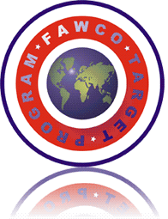
FAWCO, The Federation of American Women's Clubs Overseas, Inc. is an international network of over 70 independent organizations whose mission:
- To serve as a resource and channel of information among its members;
- To provide a voice for American women abroad and to support the rights of all Americans worldwide;
- To contribute actively to the global community with a specific focus on education, the natural and human environment, multicultural understanding and international goodwill
The FAWCO Target Program is a four year program to bring a critical global issue to the attention of FAWCO organizations, their members and to the world. It is a focused strategy of first education/awareness and then project fundraising that highlights an issue and look for ways to solve the problem and in doing so assists in attaining the UN Millennium Goals. The issue selected for the first Target program is access to safe clean drinking water, part of the UN Millennium Goal of environmental sustainability which is to, “halve, by 2015, the proportion of the population without sustainable access to safe drinking water and basic sanitation.

The FAWCO Target Water Project is an important part of FAWCO´s commitment as a recognized NGO at the UN to support the UN Millennium Development Goals. Tabitha, Cambodia - Wells for Clean Water will be the recipient of the FAWCO clubs’ fund raising efforts.

The FAWCO Foundation, the philanthropic arm of FAWCO, is supporting FAWCO Member organizations with the fundraising for the FAWCO Water Target Project. They have already begun to receive donations for the project and in June 2011theywill launch “Well” Deserved Desserts, a web-based campaign to aid individual FAWCO Member organizations with fundraising for this project. Assisting an international network of organizations large and small with ideas, by providing guidelines and support with the aim of putting the “fun” back into fundraising. “Well” Deserved Desserts will run through December 2012. An update on the campaign will be made at the FAWCO Conference in Dublin in March 2012 and the final results will be announced at the FAWCO Conference in March 2013.

THE FAWCO TARGET WATER PROJECT

TABITHA CAMBODIA-WELLS FOR CLEAN WATER

Tabitha, Cambodia -Wells for Clean Water was one of 12 proposals submitted for the FAWCO Target Water Project. It was selected from the three finalists by a vote of FAWCO Member organizations.
Tabitha –Cambodia was started in 1994. Its activities are to help those people whose lives were decimated by a Pol Pot, a regime that promoted enforced starvation, mass executions, and slave labor and decimated the Cambodian population. It destroyed the social, moral and economic fiber of the country and most wells in countryside.
The Tabitha Wells program runs in parallel to the “Family Development through Savings” program. The majority of families enrolled in the Savings Program have no access to clean water. Villagers and animals now use open ponds or rivers which are often polluted, resulting in diarrhoea and other infectious diseases. The nearest source of clean water may be several kilometers away.
FAWCO’s goal is to raise $80,000 to build family and field wells in Cambodia, allowing sustainable access to water to nearly 2000 Cambodian families which will help to lift them from poverty and despair, into lives of dignity and hope, and active participation in their communities. Family wells can be constructed for as little as $100 and field wells or as little as $250.

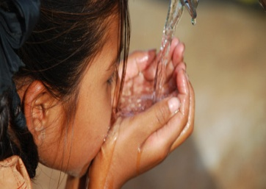
The impact of access to clean water through the installation of wells on families is immediate and significant. There is a decrease in the incidence of diarrhea and skin infections in the families. Within weeks, they gain weight; their eyes lose that haunted, dry look and their ability to work increased by several hours a day.

Each well becomes the responsibility of the family after construction. They receive training in the proper maintenance of their well from the contractor. These families are required to grow vegetables and rice and to earn an income from the wells. For more info, go to: www.fawcofoundation.org

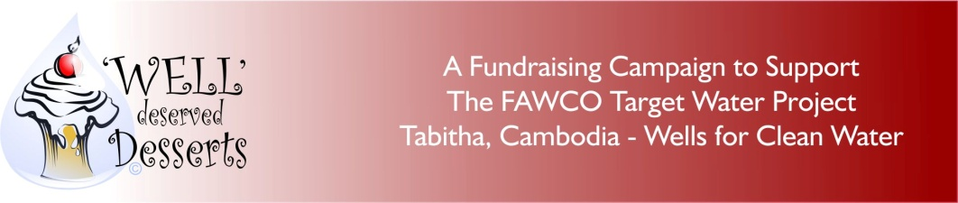

CHOCOLATE-

Need We Say More?

Here’s a chocolate event with a “blast from the past”.

(Your Club’s name here) is hosting a 70’s (or 80’s) Styled Fondue Party”?
We all remember when “fondue parties’ were all the rage. Appetizers and main course items dipped in cheese or oil and dessert was a luscious creamy chocolate sauce heated in a pot warmed by Sterno. Bananas, strawberries, biscuits you name it, we dipped it.

Now we know what you’re thinking, who has a fondue pot these days? To be honest, LOTS of us! We put a call out to our members and we have uncovered a treasure trove of fondue pots which we are going to fill with luscious, creamy chocolate sauce.

We invite everyone to dress up in their John Travolta “Fever” gear-or, and (we know some of you have them) that dress with the BIG shoulder pads. We are planning a great event for a good cause.

There will be tasting stations, each with a different theme using many different “dipping” items. We are going to try (your local specialty) to see how it tastes smothered in chocolate

There will be prizes for the most unusual “dipping item” and the best costume. We have downloaded some of our favorite music, to dance off some of the chocolate! We look forward to a very successful event!

YOUR CLUB LOGO PASTED HERE)

Dear (Prospective donor’s name)

(Your club’s name) is organizing the “70/80s Fondue Party” event in support of the FAWCO Target Water Project. The event will be held on (the date).

We are asking for your support in making this event a big success. As you have read, participants will receive a thank you gift for the generous donation that are making to the project Tabitha, Cambodia-Wells for Clean Water. We are asking local business and organizations to help by donating the gifts for the event.

Our goal is to raise (amount). This will help provide (divide 100 into the amount you hope to raise-if necessary convert your currency into dollars first!) wells to deserving families in Cambodia.

We will recognize your company in our information about the event as well as in our club’s newsletter. (Or whatever your club feels is an appropriate acknowledgement)

(The name of the person who) is in charge of donations for “70s/80’s Fondue Party”. She will arrange with you the best way to have your donation delivered for the event and answer any of your questions.

(Your club’s name) thanks you in advance for your generosity in advance. We believe that our 70/80’s Fondue Party Event will be a great success because of your help.

Together with you we will be able to change lives by providing sustainable access to clean water to people who are in desperate need. Your support of the FAWCO Target Water Project will help to “change the flow”.

Sincerely,

