The FAWCO Target Water Project
Well Deserved Desserts-“Drinks and Dessert” Event
Press Release for Club Newsletters and magazines
Please note! There is information that has purposely been left blank as well as optional information for you to include or not –Please remember to fill in the appropriate information. Also feel free to edit or add to the article as you wish.
6/1/2011

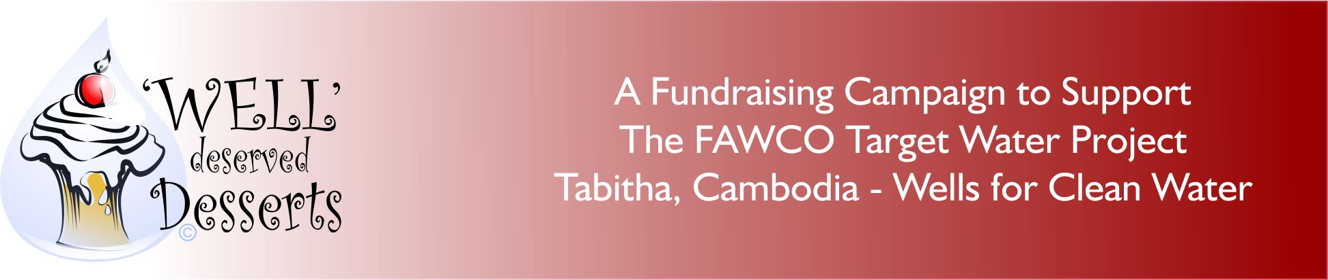

“Drinks and Dessert”
A Sweet Way to Help the FAWCO Target Water Project
Date: __________
Time: __________
Place: _________
Admission Cost: __________
Tasting Tickets:___________

Join (Your club’s name) for some fun as we host “Drinks and Dessert”! - A fundraising event that will take us on a journey of tastes combining sumptuous desserts with delicious wines/spirits.

This fund raising event is part of the “Well” Deserved Desserts campaign developed by The FAWCO Foundation, the philanthropic arm of FAWCO, to provide support to all FAWCO clubs in raising money for the FAWCO Target Water Project, Tabitha, Cambodia-Wells for Clean Water.

FAWCO’s goal is to raise $80,000 to build family and field wells in Cambodia, allowing sustainable access to water to nearly 2000 Cambodian families which will help to lift them from poverty and despair, into lives of dignity and hope, and active participation in their communities. Family wells can be constructed for as little as $100 and field wells or as little as $250. (For more information about the project please go to: http://www.fawcofoundation.org/index.php?option=com_content&view=article&id=153&Itemid=126 )

The theme of this event is Desserts and Drinks from (name the region/city/etc-or your own theme) Tasting tables will be arranged to represent this rich and bountiful geographic region known for (what is it known for?). The desserts and drinks pairings are based on matches selected from a finely edited selection of dessert and drink pairings. The admission ticket to the event will provide the participant with a wine glass, dessert plate, and fork and an evening of wonderful foods and flavors. “Tasting tickets” will be used to purchase one pairing of dessert and drink. An individual can try as many of the delicacies as they’ve purchased tasting tickets, much like going to a Gourmand Exposition!

There will also be a very special tasting (an old, old port or top end champagne for example) that is so unique it will require 2 tickets for a tasting!

Thanks to (committee, local businesses volunteers) for generously supporting this event!

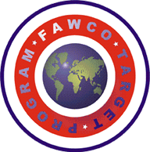The FAWCO Target Program is a four year program to bring a critical global issue to the attention of FAWCO Clubs, their members and to the world. It is a focused strategy of first education/awareness and then project fundraising that highlights an issue and look for ways to solve the problem and in doing so assists in attaining the UN Millennium Goals. The issue selected for the first Target program is access to safe clean drinking water, part of the UN Millennium Goal of environmental sustainability which is to, “halve, by 2015, the proportion of the population without sustainable access to safe drinking water and basic sanitation.

We look forward to seeing you there, having some fun and raising money for this great project!

