The FAWCO Target Water Project
Well Deserved Desserts-“70’s or 80’s Fondue Party” Event
Press Release for Club Newsletters and magazines
Please note! There is information that has purposely been left blank as well as optional information for you to include or not –Please remember to fill in the appropriate information. Also feel free to edit or add to the article as you wish.
6/1/2011

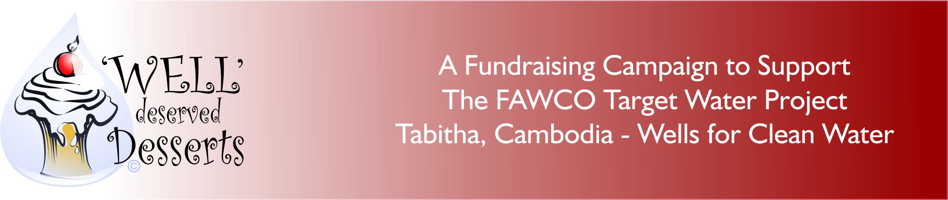

“Back to the 70’s (or 80’s”)
A Sweet Way to Help the FAWCO Target Water Project
Date: __________
Time: __________
Place: _________
Cost: __________

Join (Your club’s name) for some fun as we host a“70’s (or 80’s) Fondue Party”! - A time tested winner with a vintage twist.

Back in the day, “fondue parties’ were all the rage. Appetizers and main course items dipped in cheese or oil and dessert was a luscious creamy chocolate sauce heated in a pot warmed by Sterno. Bananas, strawberries, biscuits you name it, we dipped it. Now we know what you’re thinking, who has a fondue pot these days? To be honest, LOTS of us! We put a call out to our members and we have uncovered a treasure trove of fondue pots which we are going to fill with luscious, creamy chocolate sauce.

We invite everyone to dress up in their John Travolta “Fever” gear-or, (we know some of you have them) that dress with the BIG shoulder pads.

This fund raising event is part of the “Well” Deserved Desserts campaign developed by The FAWCO Foundation, the philanthropic arm of FAWCO, to provide support to all FAWCO clubs in raising money for the FAWCO Target Water Project, Tabitha Cambodia-Wells for Clean Water.

FAWCO’s goal is to raise $80,000 to build family and field wells in Cambodia, allowing sustainable access to water to nearly 2000 Cambodian families which will help to lift them from poverty and despair, into lives of dignity and hope, and active participation in their communities. Family wells can be constructed for as little as $100 and field wells or as little as $250. (For more information about the project please go to: http://www.fawcofoundation.org/index.php?option=com_content&view=article&id=153&Itemid=126 )

There will be tasting stations, each with a different theme using many different “dipping” items. We are going to try (your local specialty) to see how it tastes smothered in chocolate. There will be prizes for the most unusual “dipping item” and the best costume. We have downloaded some of our favorite music, to dance off some of the chocolate! Other surprises are in store. We look forward to a very successful event!

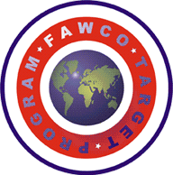The FAWCO Target Program is a four year program to bring a critical global issue to the attention of FAWCO Clubs, their members and to the world. It is a focused strategy of first education/awareness and then project fundraising that highlights an issue and look for ways to solve the problem and in doing so assists in attaining the UN Millennium Goals. The issue selected for the first Target program is access to safe clean drinking water, part of the UN Millennium Goal of environmental sustainability which is to, “halve, by 2015, the proportion of the population without sustainable access to safe drinking water and basic sanitation.

We look forward to seeing you there, having some fun and raising money for this great project!

