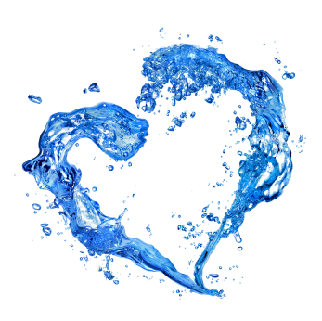
10 Things You Can Do

Water is the basis of life, and on this planet only a tiny share—less than one percent of all water—is available for nearly 7 billion people and a myriad of freshwater aquatic ecosystems. It's that tiny share of freshwater that we have to use to meet all of our needs—irrigation, industry, drinking water, and sanitation—and the needs of thousands, if not millions, of other species that we share the planet with.

The average American lifestyle demands 1,800 gallons a day to support, with 70 percent of that going to support our diets. If each of us learned how to conserve just a little more water, it could add up to big savings. National Geographic's Freshwater Fellow, Sandra Postel, thinks you should start with these simple changes:

- Choose outdoor landscaping appropriate for your climate. Native plants and grasses that thrive on natural rainfall only are best. (Read more in National Geographic Green Guide's "Plants That Will Suck Your Yard Dry.")

- Install low-flow showerheads and faucet aerators. Because you’re saving hot water, you’ll also reduce your energy bill. (More at "Bathroom Revamp: Savings by the Gallon.")

- If you’re in the market for a toilet, buy a low-volume, ultra low-volume, or dual-flush model. (Read Green Guide's "Toilet Buying Guide.")

- Fix leaky faucets. All those wasted drops add up—sometimes to 10-25 gallons a day. (Learn more on the U.S. Environmental Protection Agency's, or EPA's, WaterSense website.)

- Run your dishwasher and washing machine only when full. When it’s time to replace them, buy a water- and energy-efficient model. Remember, saving water saves energy, and saving energy saves water. (Read Green Guide's "Dishwasher Buying Guide.")

- Eat a bit less meat, especially beef. A typical hamburger can take 630 gallons to produce. (Learn more about the water embedded in your food with National Geographic's "The Hidden Water We Use" interactive.)

- Buy less stuff. Everything takes water to make. So if we buy less, we shrink our water footprint.

- Recycle plastics, glass, metals, and paper. Buy re-usable products rather than throw-aways, as it takes water to make most everything.

- Turn off the tap while brushing your teeth and washing the dishes. Shave a minute or two off your shower time. Millions of people doing even the little things makes a difference.

- Know the source of your drinking water—the river, lake, or aquifer that supplies your home. Once you know it, you’ll care about it. You just won’t want to waste water. (Find out more about your water sources with the EPA's "Surf Your Watershed" interactive.)

For more information on what you can do to preserve our precious water supply, visit:
National Geographic: environment.nationalgeographic.com/environment/freshwater
The UN, Water for Life: www.un.org/waterforlifedecade

