Butterfly Brigade – FAWCO Friendship Quilt 2018

After the amazing FAWCO Conference in Mumbai, with the beautiful Butterfly Warrior logo, I have butterflies on the brain. So let’s do a butterfly quilt! Here’s the plan:

Cut 6 green strips, each 1.5” wide and 7” long. Sew together to make a square and trim to a perfect 6.5”. We need a lot of these for the background. Here’s the idea:
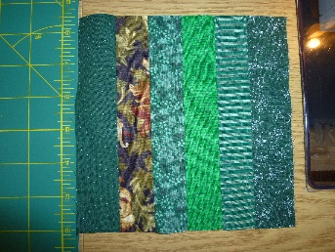
OR
Make a butterfly. These also need to be 6.5” square. Here are some links.
https://lillyella.com/2015/09/02/butterfly-charm-block-paper-piecing-patterns/ These butterflies are for experienced paper piecers. You will need to print out the design and extend the background to make it big enough, because the patterns are only 5.5”.
You could also applique a butterfly, or just find a 6.5” square of butterfly fabric.
Here’s a simpler pieced block: http://www.quilterscache.com/B/ButterflyBlock.html. And a photo tutorial:
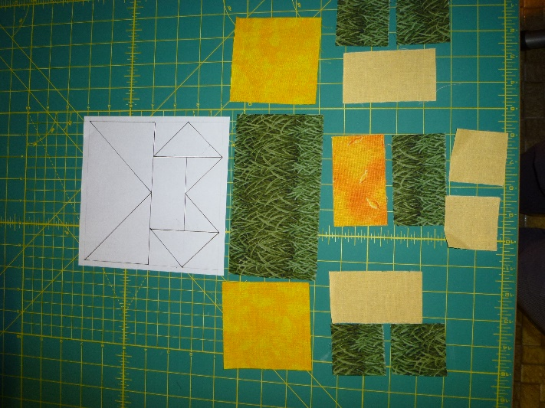 | Cutting  Background (green in this one):  - 3.5” x 6.5” rectangle  4 2” squares  - 2” x 3.5” rectangle  Upper wings (bright yellow)  - 3.5” squares  Lower wings (light yellow)  - 2” x 3.5” rectangles  - 2” squares  Lower wing center (dark yellow)  1 2” x 3.5” rectangle

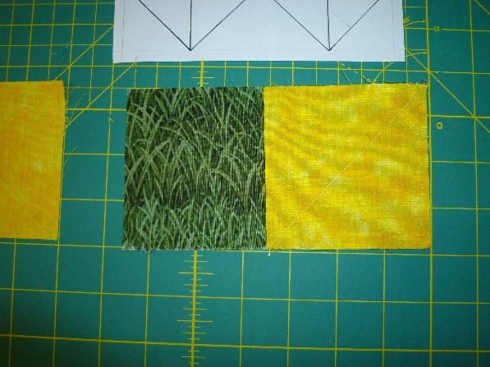 | First we’ll make a “flying geese” unit.  Draw a pencil line diagonally across both 3.5” squares (on the reverse side!). Match a square to one end of the 3.5” x 6.5” rectangle and sew on the line.  Fold the square on the sewn line to check that the corners match. If they don’t, do over. Press. (Some people prefer not to trim away the 2 extra layers underneath. I trim mine and press the seam open.)

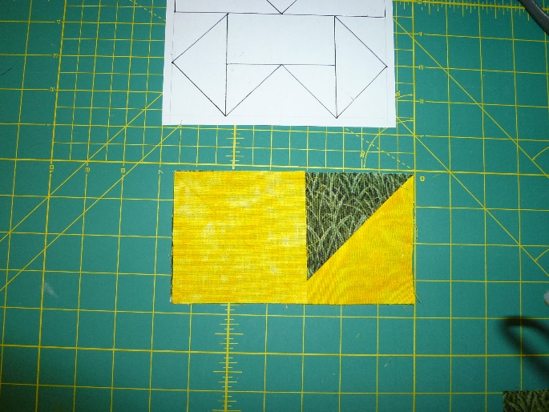 | Do the other corner the same way.  Here’s how it looks on the back after pressing (assuming you trimmed.)  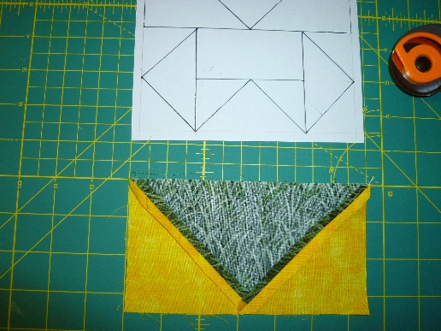

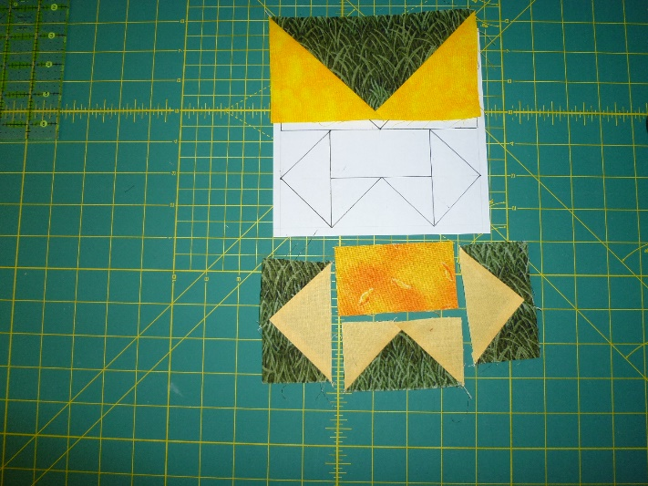 | Make the remaining flying geese units the same way. Here are all my units ready to put together.  And here’s the result .  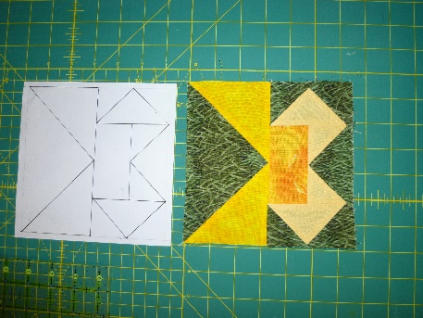

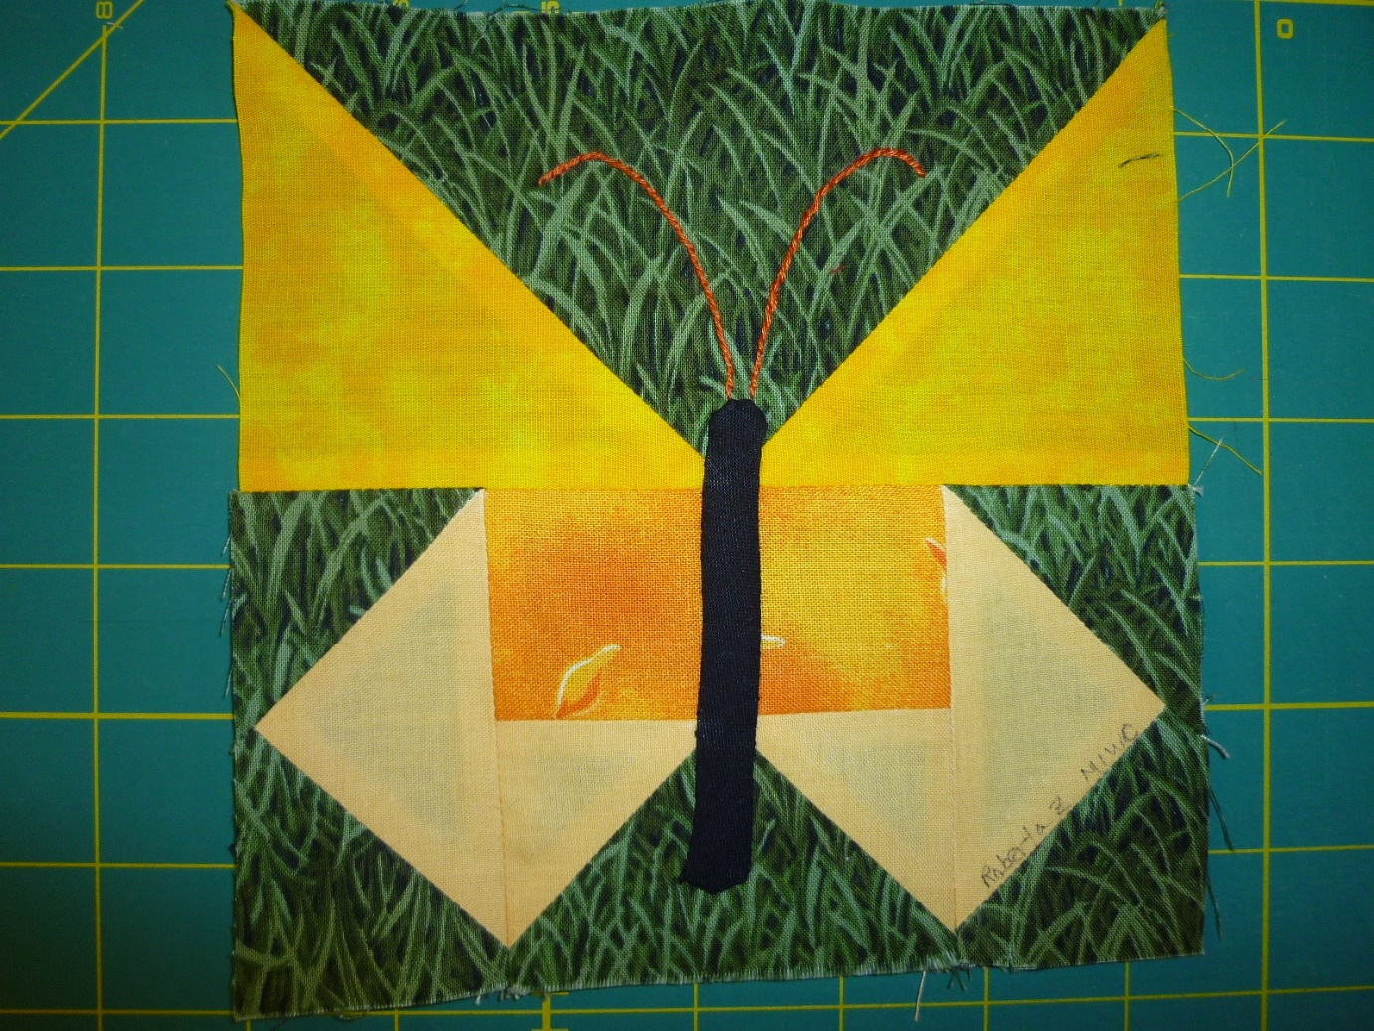
I appliqued a body and embroidered antennas. The signature is a Pigma Micron acid-free permanent pen.

Deadline 10 October 2017. Please email me right after you post your envelopes. Then I can let you know when they arrive.
Please use 100% cotton fabric. I’m hoping to get about 2/3 green stripe background squares and 1/3 butterflies. Make as many as you want, but please don’t feel obliged to make both if you don’t want to. If you don’t want to piece a green stripe square, then a square of textured green is OK too. And you don’t have to do this particular butterfly or use these colors (although I personally think a green background will work best). Find one you like! It will all work out. Our closing speaker at the Conference, Jodie Sovak, gave us a great quote from the film “Best Marigold Hotel”: “It will be alright in the end. If it is not alright, it is not yet the end.”
Questions? rl.zollner@gmx.net

