**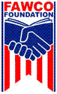HOW TO DONATE TO THE FAWCO FOUNDATION DEVELOPMENTS GRANT FUND**

**IT’S EASY!**

1. Go to The FAWCO Foundation website: [www.fawcofoundation.org](http://www.fawcofoundation.org/)

2. Click on “Donate—*Make a Difference*” in the top right corner of the page

3. Select any of three easy methods of payment: Pay Pal, check or bank transfer.

4. If paying by Pay Pal click on **“Donate”** in the Development Grants Fund box in the right side column of the page.

5. If paying by wire transfer or check follow the directions on the main donation page.

**THANKS FOR MAKING A DIFFERENCE!**

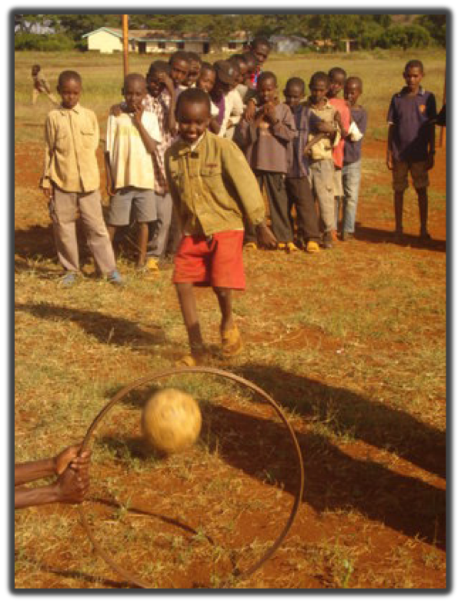

*FAWCO is a network of independent American and international volunteer organizations representing private-sector American citizens overseas. In 1967, [FAWCO](http://www.fawco.org" \t "_blank) established a* ***THE FAWCO Foundation*** *to carry on its long tradition of donating to relief organizations, providing educational support to members and their families and supporting charitable projects supported by FAWCO member clubs.* ***The FAWCO Foundation’s*** *sole purpose is to put into action FAWCO’s stated interest in the global community by specifically aiding charitable, scientific and educational programs and supporting the rights of women and children throughout the world. For over 40 years, The Foundation has stayed true to this purpose.*

***The FAWCO Foundation*** *is the philanthropic arm of FAWCO. A US 501(c) 3 organization, it is incorporated in the State of Missouri as a not-for-profit corporation. All direct donations are tax exempt in the U.S. to the full extent allowed.*

****



**THE FAWCO FOUNDATION**

**DEVELOPMENT GRANTS FUND**

***Contributing to the Sustainability and***

***Success of Global Projects***

The FAWCO Foundation Development Grants Fund reflects the passions and interests of FAWCO Member organizations. Each organization may nominate two charitable projects that they have been supporting for at least a year. **The grant categories are aligned to the UN Millennium Goals.** The FAWCO Foundation annually offers between 6-8 grants and each grant is usually $4,500.

**The purpose of The FAWCO Foundation Development Grants is to fund projects that can make an immediate impact on and lead to success for the people that they support.** FAWCO Member organizations have been aiding worthy and reputable charitable projects throughout the world through The FAWCO Foundation for over 45 years. Some organizations are working “hands-on” with their projects, others making donations of goods or financial contributions.

Most of these projects fall under the radar of large grant and charitable programs.

**FAWCO Member organizations are passionate about supporting projects that improve the human condition throughout the wor**ld. They believe that assistance should be direct, immediate and have a sustainable goal. THE FAWCO Foundation Development Grants provide the financial assistance that can help them achieve those goals.

**Our Projects**

**Since the beginning of the program, The FAWCO Foundation has awarded over $300,000 to nearly 100 projects spanning 78 countries**. The grants are funded through donations made by FAWCO Member organizations, their individual members and FAWCO Foundation fundraising activities. **The number of grants awarded each year is based on the amount of annual donations.**

Some recent projects include:

 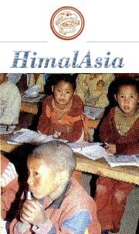 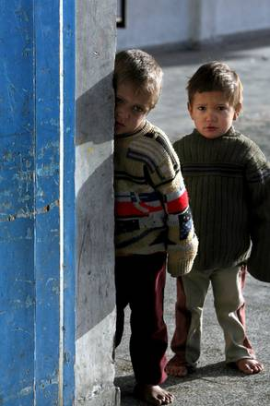

* Building a haven to protect and rehabilitate child soldiers in Kenya
* Promoting educational parity between boys and girls by constructing a school for girls in Katmandu, Nepal.
* Funding surgical procedures for children in the Middle East and Africa who suffer physical pain and psychological indignity from muscular-skeletal deformities

The projects are submitted by FAWCO Member organizations and vetted by a committee. The projects are placed on a ballot and all FAWCO Member organizations cast their ballots to determine the recipients. They are announced at the annual FAWCO conference.

The FAWCO Foundation receives two progress reports from the Development Grants recipients. A summary of some of the current projects is on The FAWCO Foundation website: [www.fawcofoundation.org](http://www.fawcofoundation.org)

**How YOU can Help Us Continue to Make a Worldwide Impact**

The FAWCO Foundation is proud of the support that FAWCO Member organizations give to charitable organizations and the impact that the Development Grants Fund has made on so many of their projects.

We know that “starting small” helps these projects achieve realistic and practical goals. One Development Grant will not save the world, but it can save a life, offer education or provide needed jobs to those whose voices are not always heard.

**YOU can:**

* **Make a donation to The FAWCO Foundation Development Grants Fund.**
* **Support a fund raising drive at a FAWCO Club to fund a Grant**
* **Ask your employer, local business or organization to match your donation**

All donations will be acknowledged and are US tax deductible to the fullest extent of the law. Information about sponsorship is available from The FAWCO Foundation.

We know that this is a difficult economic time, but it does not make these projects any less of a priority-it makes them even more important.

**The FAWCO Foundation knows that your donation will have an immediate and long lasting impact on the recipients of the FAWCO Foundation Development Grants. Donations now will insure the future of this program!**

**