**THE FAWCO FOUNDATION REPORT**

**Annual Report 2014**

The FAWCO Foundation is the philanthropic arm of FAWCO and is a not-for-profit 501(c)(3), incorporated in the state of Missouri.

**2013-2015 FAWCO Foundation Board of Directors**

President Michele Hendrikse Du Bois Munich IWC

VP Communications Cynthia Smith-Ayed AIWC Casablanca

VP Fundraising Suzanne Wheeler AAWE Paris

VP Programs Nan de Laubadère AAWE Paris, FAUSA

Treasurer Kathy Coughlan FAUSA

Secretary Margaret Hilditch Munich IWC

Parliamentarian Elsie Bose AWG Paris

**Special Appointment to the Board (non-voting)**

FAWCO President My-Linh Kunst AWC Berlin

The theme of the Rome Biennial Conference is “The Eternal Woman – Equality, Protection, Empowerment”. Joan of Arc, Queen Isabella, Pocahontas, Catherine The Great, Sacagawea, Harriet Beecher Stowe, Queen Victoria, Elizabeth Cady Stanton, Susan B. Anthony, Florence Nightingale, Harriet Tubman, Clara Barton, Louisa May Alcott, Gail Laughlin, Helen Keller, Marie Curie, Sirimavo Bandaranaike, Benazir Bhutto, Rosa Parks, Wangari Maathai, Mary Wollstonecraft, Wilma Mankiller, Eleanor Roosevelt, Georgia O’Keeffe, Amelia Earhart, Margaret Chase Smith, Margaret Mead, Mother Teresa, Rosa Parks, Margaret Thatcher, Sandra Day O’ Connor, Jane Goodall, Gloria Steinem, Barbara Jordan, Madeleine Albright, Hillary Rodham Clinton, Oprah Winfrey. A *much* abbreviated list of the many women – Eternal Women - who throughout history have fought for equality, protection and empowerment.

FAWCO has been empowering women since 1931. Created in 1967, The FAWCO Foundation’s sole purpose is to put into action FAWCO Member Clubs’ stated interest in the global community by specifically aiding charitable, scientific and educational programs and supporting the rights of women and children throughout the world.

I want to thank The FAWCO Foundation’s amazing Board for their continued support and diligent work on behalf of The Foundation. We have shared a busy, challenging, fun and successful 3 years together. During our term, there have been moves (by almost every member), health issues for members and family, children’s weddings, grandbabies born, a few “big birthdays” and many other life events. Through it all, the Board worked together as a team, supporting each other when support was needed and making sure The FAWCO Foundation remained a healthy organization supporting the programs FAWCO Member Clubs want to support. I will miss working with these wonderful women and wish them success in their next endeavors.

The FAWCO Foundation had a very successful 2014, but we can only do what we do with the very generous support of individuals, FAUSA and FAWCO Member Clubs. As always, our heartfelt thanks go out to each and every one of you who support The FAWCO Foundation’s programs.

***Here are a few highlights from 2014:***

* Foundation Night 2014, with the theme of “Around the World in 80 Bids”, raised over $34,000.
* All but one 2015 Development Grant was fully funded by direct donations.
* AWG Paris offered to sponsor the “IT Award for Young Women” for three years.
* The FAWCO Foundation added a new Member Award, “IT Award for Members” and increased the amount of the “Dual Cultural Award” to $3,000.
* At least one Board Member attended all but one Regional Meeting (Region 9) and the FAUSA Getaway.
* A new format was created for The Foundation’s website making navigation easier.
* Since The Foundation started funding NEEED Scholarships in 2010, 34 young women from Burkina Faso have been given the opportunity to pursue post-secondary education thanks to FAWCO members.
* The Board approved a complete update of the Foundation’s governing documents.
* The Board continued to develop the Backing Women Fundraising campaign supporting the Target Project. Total fundraising to-date is nearly $67,000. Based on a timeline comparison with the previous Target program, Club support has not met the previous year-to-date donations. It is important to remember that the Target program was created as global club-based fundraising activity. The Foundation is optimistic that clubs will focus on attaining their $120,000 goal and it will continue to assist the clubs in their efforts.

**2014 BOARD REPORTS:**

**THE FAWCO FOUNDATION PROGRAMS – VP PROGRAMS, NAN DE LAUBADÈRE**

**DEVELOPMENT GRANTS (DGs)**

The Interim Reports from the 2014 Development Grant recipients are due the end of January so at the time of this writing they are not yet available. Details of their progress will be announced in March at the conference in Rome. These projects in total received $36,000 almost all of which was funded by FAWCO clubs or from individual member support. The recipients and their sponsoring clubs were:

**AW OF SURREY HOPE THROUGH EDUCATION**, ***Hope for Haiti’s Kids***, www.hopeforhaitiskids.org, *Nominated by AWC Bern*. This small non-profit organization was founded to respond to Haiti’s earthquake.

**PAM DAHLGREN EDUCATING AFRICA’S CHILDREN**, ***Mama Norah Education Center****,* www.kenyaprojektet.se, *Nominated by AWC Stockholm*. This project funds a school built to educate orphans and extremely poor children in Wagwe, Kenya.

**FAUSA WATER RUNS THROUGH IT**, ***The Kenya Project Clean Water Initiative***, www.kenyaprojektet.se, *Nominated by AWC Stockholm*. This project will install a water filter and pump house to provide clean drinking water for Wagwe citizens.

**AWC SHANGHAI A WORLD OF POSSIBILITIES**, ***Madagascar School Run by Ursulinnes Nuns****, Nominated by AILO Florence*. The grant will be used to install solar panels to allow children enough light to stay more connected with life, provide power for a refrigerator and possibly a computer.

**AWC THE HAGUE CRITICAL HEALTH CONCERNS**, ***Jack & Jill Foundation***, www.jackandjill.ie, *Nominated by AWC Dublin*. The grant will provide home nursing care to brain damaged children up to the age of 4.

**THE COUGHLAN FAMILY FOUNDATION PREVENTION OF INFECTIOUS DISEASE**, ***Friedensdorf International****,* www.friedensdorf.de, *Nominated by AWC Dusseldorf*. The grant will go to constructing a maternity and children`s ward in Svay Rieng, Cambodia.

**AMERICAN WOMEN OF THE EASTERN PROVINCE SKILLS FOR LIFE**, Sponsored in part by AILO Florence, ***Amal Women’s Training Center***, www.drosos.org, *Nominated by AIWA Marrakesh*. The Amal Women's Training Center gives underprivileged women a chance to learn a marketable skill in the restaurant industry

**AROUND THE CORNER, A WORLD AWAY**, Sponsored in part by AIWC Genoa in memory of Carol Bordoni, ***Assertiveness/Self-Defense Training for Victims of Domestic Abuse***, www.frauenhaus-muenchen.de, *Nominated by IWC Munich*. The grant will cover assertiveness/self-defense workshops for women and children, victims of domestic abuse.

***The Foundation thanks Kelly Al-Nashmi and her committee for overseeing the 2014 DG program.***

In 2015 The FAWCO Foundation is pleased to be able to offer 8 DG’s, each worth $4,500, again almost entirely sponsored by FAWCO clubs or individual members. These grants are:

**AW OF SURREY HOPE THROUGH EDUCATION**

**PAM DAHLGREN EDUCATING AFRICA’S CHILDREN**

**FAUSA WATER RUNS THROUGH IT**

**AWC SHANGHAI A WORLD OF POSSIBILITES**

**CRITICAL HEALTH CONCERNS,** fully sponsored by an anonymous FAWCO member club

**THE COUGHLAN FAMILY FOUNDATION PREVENTION OF INFECTIOUS DISEASE**

**AMERICAN WOMEN OF THE EASTERN PROVINCE SKILLS FOR LIFE,** sponsored in part by AILO Florence

**AROUND THE CORNER A WORLD AWAY**, sponsored in part by Julie Mowat, Laurence and Margaret Hilditch and AIWC Genoa in memory of Carol Bordoni

**EDUCATION AWARDS (EAs)**

Progress reports from the 2014 Education Award recipients are due the end of January so updates about them and their programs will be announced at the Rome conference in March. The recipients were:

**SCIENCES AWARD** $3,500  Sponsored in part by AIWC Genoa, in memory of Frieda Bacigalupo Natali, and AWC Zurich.

**Austin Gahrs**, son of a North American Connection member, was planning to study Chemical or Computer Engineering hoping to focus on chemical interactions of nanoscale structures.

**HUMANITIES AWARD** $3,500  Sponsored in part by AAWE, in memory of Gertrude de Gallaix.

**Martha Masoero**, daughter of a member of the IWC Turin was working towards graduating from Oxford University in July 2014 and then pursuing a Master’s Degree in Social Policy.

**VIOLA WHEELER ARTS AWARD** $4,000

**Noah McGuire**, son of a member of the AWA Rome, was expecting to graduate High School in May 2014 and then attend university in the US to study Music Production.

**DUAL CULTURAL AWARD** $1,500 Sponsored in part by Donna Erismann and AWC Bern, in memory of Suzanne Erismann

**Alexander Nielsen**, son of a member of the AWC Denmark, a Danish and US citizen, was planning on spending the 2014-2015 school year at an American high school.

**FAWCO and FAUSA Member Awards**

**AWC BASEL AWARD FOR UNIVERSITY DEGREE STUDY PROGRAMS** $5,000 Sponsored by Shirley Kearney

**Madaline Keros**, a member of IWC Munich, was planning to become a “cultural integration specialist, working with Italians, French, Anglophones and refugees to help them feel more settled and integrated in the city so that they can make fruitful contributions of talent and expertise.”

**FAUSA SKILLS ENHANCEMENT AWARD**  $4,000

**Elizabeth Sanders**, a member of AWA Rome, was planning to seek a Certificate in Botanical Art & Illustration from Wellesley College Botanic Garden, which would enhance her opportunities to share her expertise through educational courses and seminars as well as donations of her work.

***The Foundation thanks Carmen Clarke and her committee for overseeing the 2014 Education Awards.***

In 2015 The FAWCO Foundation is thrilled to offer 7 Education Awards and they are:

**AWG Paris IT AWARD FOR YOUNG WOMEN** $3,500

**Viola Wheeler ARTS AWARD** $4,000

**SCIENCES AWARD** $3,500, Sponsored in part by AIWC Genoa, in memory of Frieda Bacigalupo Natali, and AWC Zurich

**HUMANITIES AWARD** $3,500, Sponsored in part by AAWE, in memory of Gertrude de Gallaix

**DUAL CULTURAL AWARD** $3,000, Sponsored in part by Donna Erismann and AWC Bern, in memory of Suzanne Erismann

**FAWCO and FAUSA Member Awards**

**AWC BASEL AWARD FOR UNIVERSITY DEGREE STUDY PROGRAMS** $5,000 Sponsored by Shirley Kearney

**FAUSA SKILLS ENHANCEMENT AWARD** $4,000

**WOMEN IN TECHNOLOGY AWARD** $3,500

**NEEED SCHOLARSHIPS**

NEEED is a program based in Burkina Faso which provides post-secondary education studies for girls in the fields of primary school teacher training, nursing, midwifery and university studies.

Generous donations totaling $41,878 and a slightly higher exchange rate in 2014 enabled us to provide three university scholarships, three scholarships for midwifery training and three scholarships for primary school teacher training. The primary school teacher trainees this year expressed a desire to help their communities, brothers and sisters and encourage women to send their children to school, especially daughters, which is most encouraging. The Foundation wishes all the students much continued success.

**FUNDRAISING – VP OF FUNDRAISING, SUZANNE WHEELER**

I wish to thank all the fun-raising volunteers who through their contributions small and large, club level or individual efforts, have made this a very successful year for our Foundation fundraising. My work has been made so much easier by having a fabulous caring team every step of the way.

2014 has again been a year of new initiatives for The FAWCO Foundation fundraising team. Tried-and-true programs continued to be the main avenue of income generation for the four core programs. Again trends were analyzed resulting in one major recommendation - an online auction - for improving the conference fundraising evening experience. We are testing it for the Rome auction. The in-house program allows for 20 items complete with photos, write-ups and videos. Colleen Gilbert as The Foundation’s Online Auction Coordinator and Catherine Connor have been instrumental in building this feature.

Grace Christovasilis, working as The FAWCO Foundation Donor Development Coordinator, teamed COCO-MAT (a high-end linen and bedding store) with clubs working on heart pillow projects. This relationship proved to be very beneficial to the participating clubs providing working space, PR, and pillows to donate to the clubs’ chosen hospitals. This relationship also resulted in a donation from COCO-MAT for The Foundation’s live auction. We thank Grace for her efforts on behalf of The Foundation.

The regional conferences, in addition to the annual conference, provide the best platforms for educating individuals about the Foundation’s programs and fundraising options. This is borne out by the success of finding sponsors for EAs and DGs resulting from these presentations. We continue to see results from Foundation Board members attending and briefing during *each* Regional meeting as direct sales and contributions from these conferences continue to improve. In addition, these presentations have helped garner support for a club’s continuing interaction with FAWCO by explaining how the organization gives back to the club. Foundation Night at the annual conference continues to be the most successful single avenue of funds’ solicitation. On-line solicitation continues to have the weakest response; getting general membership to subscribe and then utilize the site is the challenge.

**ON-GOING SALES:**

***Friendship Quilt Raffle*** –The 2014 quilt, “Endless Stairs” (72”x104”), designed and completed by Roberta Zöllner, included 63 donated blocks from 38 contributors from 17 clubs and FAUSA, raising $3,805 – an increase from 2013. Chris Czyszczewski donated the batting of this very large quilt. Margaret Hilditch, AWC Munich, was this year’s excited winner.

***Morganite Earrings Raffle*** – This is the third year we’ve run a high-end raffle. The response was up from last year netting $4,194. The lucky winner was Maria Bartolomei, AIWC Genoa. This initiative’s success is contingent upon receiving a suitable donation for the raffle far enough in advance to properly advertise the article. Three years of success confirms there is no conflict with the funding of the quilt raffle.

***Charms and Charm Bracelets*** – The Brussels’ charm was a hand-casted world in a round blue-enameled sea. AnnDi Simoni again worked with the jeweler in Genoa. Fifty charms were ordered with 46 being sold at the conference. This charm is now sold out. Overall the charm program netted $1,815 for the year, down from the year before. This apparent decrease can be partially explained by the number of complete bracelet sets sold in the previous year with leftover stock. Another reason was the cost of making the charm had increased, as had the exchange rate euro/$, so the profit margin decreased by the sell date. It was decided not to increase the price of the charm this year as we were introducing quite a few other initiatives.

**BRUSSELS CONFERENCE FOUNDATION NIGHT:**

TFF’s evening was titled “***Around the World in 80 Bids***” to reflect the theme of the conference and the diversity of FAWCO clubs. Dress was host nation’s costumes or one’s own ethnic roots. Décor was national flags and world balloons attached to baskets filled with chocolates. Entertainment varied from taking a quiz to having regional photos. And who could forget our “dress” winner, Enid Burki of AWC Bern?

***Live Auction*** – Sandy Gogel along with Clydette de Groot and their team, auctioned off 15 lots with 3 items being offered to the 2 top bidders, for a net total of $20,400 of which $6,000 was designated to the *Backing Women* campaign. So although this showed an increase over recent years, because the funds went into 2 different “pots”, the General Fund take was less than the previous year. The auction of a week’s stay in the Taj Properties was a banner bid of $6,000 - the highest ever for a Foundation auction item. Taj Properties donated this with the understanding the monies would be contributed to the *Backing Women* campaign.

***Silent Auction*** – Barbara Buehling led the Silent Auction Team, beautifully displaying over 200 items - down over the preceding year. Proceeds from this auction totaled $8,160 including $810 in the “By Women for Women” table supporting the *Backing Women* campaign. We cannot have this success without the continued support in both donations and “worker bees”.

***Chocolate Box*** – This year’s “Lucky Dip” was *The FAWCO Foundation Box of Chocolates: You Never Know What You’ll Get*. We charged $5/5€ per draw from the box; Barbara Paulhus and Judy Furukawa managed 150 donations, raising $647. They sold 140 draws. Both the sales and inventory decrease from Bern can be explained by Bern’s *Wishing Well* being buoyed in both donating and purchasing participation by *Eleanor Roosevelt’s Leadership Camp for Girls* supporters.

***Benefactors*** – For the second time we tried a Benefactors program for this event, with a successful net showing of $1,749. We included both quilt and high-end raffle tickets as an inducement for participation. This will be repeated for Rome.

**OTHER SOURCES:**

***Other Donations*** – $50,000 and $20,000 was donated by a private source for use in various areas.

***Land of the Midnight Sun Cruise*** – Ann Di Simoni put her skills to work arranging a summer fun-raising cruise through the Norwegian Fjords. There were 56 guests sailing with The Foundation raising a total of $6,500. Ann ran a bingo and a silent auction which contributed monies to this donation. Suzanne sold *Backing Women* boutique items. Ann’s cruise program included a scavenger hunt for anyone under 18 and a welcome cocktail event.

**TARGET PROGRAMS:**

Human Rights for Women – As of the end of December 2013, $2,586 had already been raised towards the 2014-2106 Target project. In anticipation of the Target Program, The FAWCO Foundation developed a fundraising campaign called ***Backing Women*** (BW). Christian de Laubadère generously donated a painting from his “Neck” series, which was used as the campaign’s image. It is to be auctioned during the Rome Conference 2015. The BW campaign (and painting) was unveiled by Marie Bénédicte Luxem and Suzanne Wheeler on Saturday of the Brussels conference after the announcement of the Target Project “Free The Girls”. Marie Bénédicte and her team developed an online boutique of unique branded items and sold Club Kits in Brussels for distribution to the clubs to use as sample goods throughout FAWCO regions. Sales from this boutique have netted over $8,000 with sales occurring during the Brussels conference, Regional meetings, other clubs’ events, and via an on-line store. Special Mother’s Day and Christmas products were advertised. Most items sold are hand-made by women entrepreneurs. All items sold include the *Backing Women* logo. A Club Matching Grant Challenge ($10,000) and an Individual Matching Grant Challenge ($5,000) were announced for 2014. Both challenges were met thereby netting an additional $15,000 towards the campaign. Julie Meyerson administered a photo competition judged by an independent panel comprised of Dr. Amy Antin, Lorenzo Fiaschi, and Guillaume Estève, with the Grand Jury and the Viewer’s Choice winners to be announced during the Rome Conference. 53% of the funds raised to-date comes from the FAWCO wide activities developed by The FAWCO Foundation. The success of the *Backing Women* campaign is measured by approximately $67,000 having been raised by year’s end through FAWCO clubs’ and the Foundations’ efforts.

**COMMUNICATIONS - VP COMMUNICATIONS, CYNTHIA SMITH-AYED**

I have continued to use the archive feature of Constant Contact, to post the News You Can Use (NYCU) on the Foundation, FAWCO, FAUSA and FAWCO Reps and Presidents Facebook pages making it easier for members to read and share. NYCU is emailed monthly to some 200 contacts including Club Presidents, Reps and donors. Any club member can sign up through a link on the home page of the website.

The website server was upgraded allowing for faster navigation on the website. The new template has been well received by the Board and readers. Information on the home page is by section and allows readers to easily find the information they are looking for. There are buttons for links to pages used most often and a highlight section for the most current information.

A great deal of information for the Target project was added to the website over the last year including fundraising resources for Reps, printable brochures and a new Donor Club page for the clubs who have raised money for the Target project. Catherine Connor, the FAWCO webwoman, has been very helpful with the technical aspects of changes and additions to the website. We are grateful to Cat for her time and patience.

PayPal buttons for quilt tickets and bracelet tickets have been added. Cat also set up a page for online auction bidding. Training was held for the various committee members and the site will be opened in January. With this and the PayPal option for raffle tickets it is hoped that more people will participate in conference fundraising initiatives.

Lastly, an attempt has been made to update all the pages of the website and edit them when necessary so that the handover to the new VP Communications will be smooth.

I would like to thank the extraordinary group of ladies I have worked with for the past three years for their dedication, patience and sense of humor. It has been an honor to serve with all of them.

**SECRETARY – MARGARET HILDITCH**

In addition to the normal activities of Secretary, 2014 has been busy with preparation for the 2015 handover to the new Board. I have set up a series of files for the collection of all the documentation required for handover. This will be determined in line with the Retention Policy Document. All minutes to date have been proofread and copies stored. A decision still needs to be taken concerning the storage of these in a cloud environment to ensure that the content is safe should any computer system crash.

Since the handover of the Archives from Roberta Zöllner, additional time has been spent reviewing the contents of the archives. I created an excel spreadsheet to gain an overview of the already scanned documents on the hard drive and then proceeded to create new files with reports pertaining to registration, audit, annual budget, president, EA, DG, Fundraising and Minutes of AGMs and interim meetings. I have a separate box containing historical information and another with copies of reports and pamphlets relevant to the three years of service by the present board. It is my goal to list all scanned documents and insert labels defining the content within each file, with notes to my successor where appropriate.

Originally the Board thought that the scanning of the documents could be assigned to a student on an internship but we now know this would have been impossible to manage. I hope that the process will have moved forward by the end of my term and my successor can continue with the work that needs to be done in order to reduce the quantity of hard copies and ensure that the Archives of TFF are in a secure and accessible place.

My time as Secretary to TFF has been an incredible journey and I sincerely thank Michele and the Board of Directors for their friendship, patience and support during these three years. It has been a wonderful highlight of my life and a memory to be treasured.

**PARLIAMENTARIAN – ELSIE BOSE**

My roles in this position were to assist the President regarding the management of meetings using Robert’s Rules of Order and to prepare draft revisions of the Bylaws and Administrative Guidelines if so requested. This was an extremely professional board of Directors. All of our meetings ran smoothly and according to “the rules”. Since the Bylaws and Administrative Guidelines had not had a thorough review since 2010 the board asked me to review and recommend suggested revisions. This board had the unique opportunity to work together for three years so they were well positioned to advise on revisions to make the Bylaws and Guidelines more relevant documents.

Starting in early spring, I worked individually with each Director. I sent each of them a questionnaire and we followed up with a Skype call. I wrote draft revisions based on their feedback. Each Director worked with me until the drafts were complete. Once the entire draft package was complete, it was sent to the President for her approval.

Upon approval the AG package was presented at the December 2014 Board meeting and the revised edition was approved.

There were four important changes to the Administrative Guidelines:

1. The “Document Retention Policy” was revised. It is now a more detailed policy. It contains a comprehensive list of not only what documents must be retained but by whom, for how long and where the documents are to be stored. The President spearheaded this revision.
2. Information regarding DG and EA sponsorship was taken out of the “Job Description” section and revised as a policy.
3. Program Summaries were added as an aid to better understand the full breadth of The Foundation’s core programs.
4. All of the job descriptions were updated to reflect each Directors’ and Appointees’ current responsibility. This should provide a reliable “road map” for future boards.

**Target Project Participation:**

I assisted the VP Fundraising and the Target Fundraising Coordinator on various aspects of the fundraising campaign.

**Target Corporate Donor Coordinator**- I prepared a donor package for potential sponsors. Since September 2013 I have mailed or distributed 11 packages and made follow-up calls and emails. I have not received any positive responses. There are a few reasons why we may not be getting any “traction” with corporate donors:

1. Some companies want the projects they support to be located in the US.
2. Many will not financially support administrative expenses as is the case with Free The Girls.
3. Donors do not understand why they would donate to FAWCO/Foundation and not directly to the project.
4. My “remote” location makes it difficult to meet with key CSR decision makers in person.

It would be helpful to have a Corporate Donor, not only for the funding it would provide, but it might help to elevate the profile of FAWCO and the Target Program to an “outside” audience. However, this is a club-driven fundraising project and the goals were set based on club participation for Target One. It would also be helpful if I had access to suggested contacts for donors from FAWCO Member Clubs or their members. This might be something to highlight going forward.

**“Backing Women” Fundraising Campaign for the Target Project.**

The Target Program Feedback committee recommended that The Foundation create a “tool kit” to assist Member Clubs with fundraising. I wrote the content for the tool kit which was uploaded to USB sticks that were distributed at the FAWCO Conference in Brussels. The Target Fundraising Coordinator sent out USB keys to clubs that did not attend the conference. The information was also added to The Foundation’s website. In early fall 2014 the tool kit and the revisions were added to the website.

I created a PowerPoint slideshow and co-presented the “Backing Women” fundraising workshop with the Target Fundraising Coordinator at the FAWCO Conference in March.

I developed a “Deep Dive Report” for the Target Fundraising Coordinator so that she can track all of her fundraising activity throughout the campaign. The report includes information from the Treasurer regarding individual and club donations, a detailed tracking system for sales and inventory for all “Backing Women” Online Boutique and merchandise sales, and a timeline from Target One that helps us measure how the current campaign is progressing in relation to the last campaign.

Working with Sunny Eades (NAC), we created the medallions for Target 2. The medallions were developed originally at the end of Target one to send to clubs based on the amount of their club’s donation. It was thought that instead of certificates of appreciation (that would have probably ended up in a file folder) clubs could use this medallion logo on their website, in their newsletters and other media as recognition of their hard work fundraising for the Target Project. For Target Two the medallions are now given out as clubs achieve medallion levels.

I developed the publicity for the “Backing Women”, Mother’s Day and the “Backing Women” Holiday Collection announcement and the Holiday Catalog. The publicity was distributed to our main mailing list via Constant Contact.

**Other:**

I updated the FAWCO Foundation pamphlets this summer. These pamphlets were developed in 2013 for Reps and Presidents to aid in describing the work of the Foundation.

There are five pamphlets: 1. “Who We Are” which describes The FAWCO Foundation, 2. The Development Grants Fund Program, 3. The Education Awards Program, 4. The NEEEDs Scholarship Program (Michele updated this one), and 5. The Target Program.

The revised pamphlets were updated on The Foundation website and now come in two formats: a printable version and a “scrollable version” for easy reading on computers.

**TREASURER – KATHY COUGHLAN**

On the following pages are the financial statements for the FAWCO Foundation. Our financial year follows the calendar year and we have included the most recent financial year (unreviewed) and the prior year (with the associated accountant’s review letter.)

Our revenues between years have increased by $75,000. The Foundation was fortunate to receive two large donations from a private donor during 2014 totaling $70,000. These donations are earmarked for specific programs. Revenues also increased for the Target Program which is in its initial year of fundraising. The net amount raised was $67,000 comprised to a large extent by Foundation projects which is expected as the Club-driven revenues should be seen during the coming year as fundraisers are held and monies remitted. To meet Free The Girls’ requested funding goal of $150,000 there will need to be vigorous support from the clubs over the next year.

Foundation Night revenues remained constant although on the attached financials they appear to have declined between the years. This is due to specific items in both the live and silent auctions being assigned directly to the Target Project in 2014 and reflected as Target income on the financial statement.

Interest rates have been very poor over the last two years. Expenses increased due to the release of monies received to specific programs. We included in-kind donations by the Board for expenses in which no cash reimbursements were made. In-kind expenses are understated in both years as the Foundation Board still under reports unpaid expenses. The Board reported unpaid expenses of $14,973 in 2014 as compared to 2013 of $13,710. During 2014 Board expenses of $9,857 were paid as compared to $9,342 in 2013. During the current year a Board member attended all but one (Region 9) of the regional meetings, which increased costs but allowed us to bring The Foundation’s goals and benefits to many more people. The in-kind expenses of the Board will vary from year to year based on the physical location of each Board member. However I feel that we now have a good baseline for the expenses of this organization.

We have also included pie charts that show the sources of income in 2014 and the areas that we expended funds in 2014. The 2014 income sources show that our income is supported by Foundation events and individual and club donations which are very much appreciated.





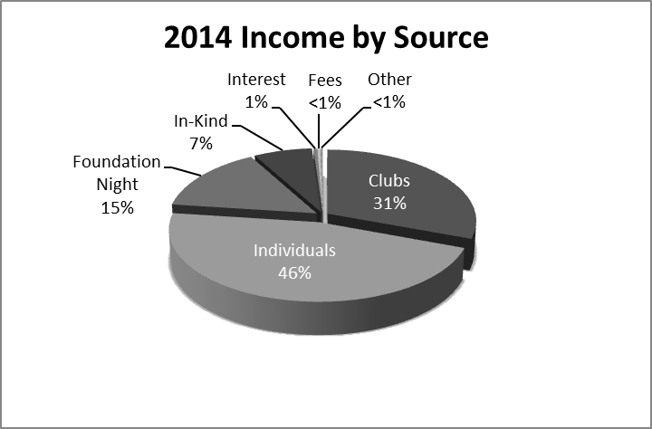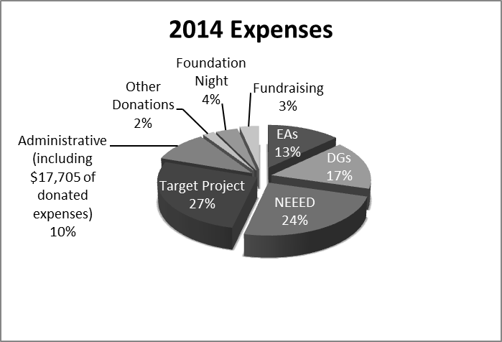

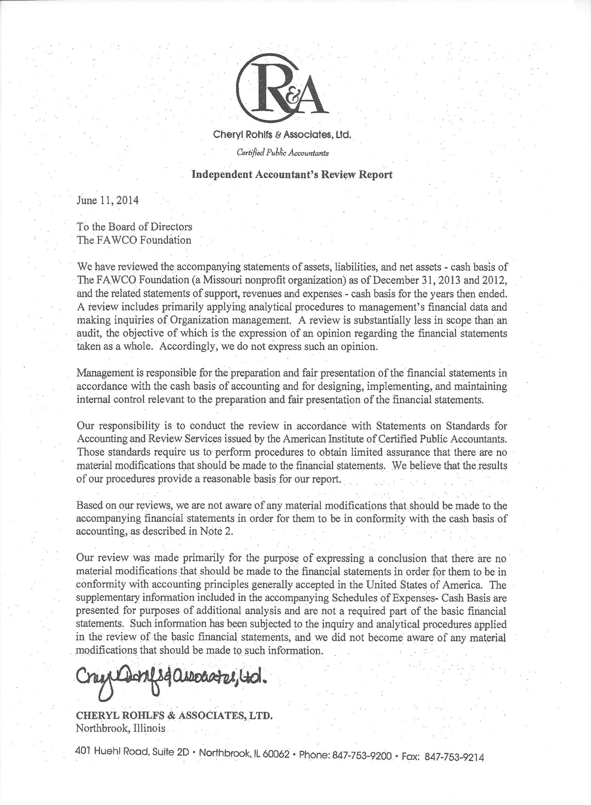

In closing, a few additional words of thanks:

I want to thank the FAWCO Board for their support over the past year. Again this year, My-Linh and I (or a substitute board member) attended all of The Foundation and FAWCO Board meetings including the on-site meetings. I have thoroughly enjoyed working with My-Linh and her Boards over the past 3 years.

I would also like to thank FAUSA President, Janet Darrow for her continuous support of The FAWCO Foundation. FAUSA remains one of The Foundation’s greatest supporters sponsoring both an Education Award and Development Grant. We continue to look at different ways FAWCO, The FAWCO Foundation and FAUSA can work together.

As always, the final thank you belongs to you, our donors and clubs, without whom we wouldn’t be here! Thank you for your continued generosity and thank you for making a difference in the world. The FAWCO Foundation is so very grateful for your support!

Michele Hendrikse Du Bois

FAWCO Foundation President 2013-2015

“Your projects, your passions, your Foundation”

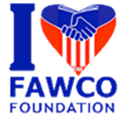

**2014 Friends of The Foundation**

*Thank you to our generous FAWCO Clubs, club members and friends!!*

|  |  |  |  |
| --- | --- | --- | --- |
| **Benefactors**  **($1,500 -$100,000)** | **Patrons**  **($750 - $1,499)** | **Donors**  **($250-$749)** | **Supporters**  **($150-$249)** |
| AAWE Paris  AIWC Cologne  AW of the Eastern Province  AW Surrey  AWC Perth  AWC Shanghai  AIWC Genoa  AWC The Hague  AWC Zurich  AWG Paris  FAUSA  🙞  Kathy Coughlan  Shirley Kearney  Margaret and Laurence Hilditch  Hugh and Sue Ripps  Viola Wheeler | AWA Rome  AWA Vienna  AWC Luxembourg  AWG Languedoc-Roussillon  Chilterns AWC  IWC Torino  🙞  Louise Greeley-Copley  Renuka Matthews  Julie Mowat | AWBS International Women’s Club  AWC Antwerp  AWC London  ­  🙞  Massimo Bacigalupo  Katherine Balfour  Elsie Bose  Deidre Brewster  Barbara Bühling  Mary Stewart Burgher  Dolores Cuellar  Nan de Laubadère  Francoise Delannoy  Johanna Dishongh  Donna Erismann  Michele Hendrikse DuBois  Monica Jubayli  Carol Kamphuis  Jeffrey Kobacker  John Kobacker  Nancy Koster-Tschirhart  Linda Lai  Carol Lalani  Patti Meek  Sheila Ohlund  Pam Perraud  Georgia Regnault  Laurie Richardson  David Shopshire  Sheryl von Blucher  Teresa Wheeler | AWC Amsterdam  North American Connection  🙞  Celeste Brown  Maureen and Carlo Cavo  Sallie Chaballier  Arline Coward  Sara Crabtree  Katelin Downing  Amanda Drollinger  Theresa Hartwell  Liz Hemminger  Juliane Maggi  Kathi Savoury  Kathleen Simon  Betsy Speer  Cheryl Steenman-Bash  Kathy Tolchinsky  Sara Von Moos |