2025 FAWCO Friendship Quilt

From “Vertical Garden” to “Octopus Oasis”
Thanks, from the Quilt Team to everyone who participated in the making of the beautiful 2024 quilt, Vertical Garden! The winner of the Quilt raffle in Porto is Mary Stewart Burgher from AWC Denmark. The raffle raised USD $2505 for The FAWCO Foundation to support its many endeavours. This makes $100,604 that the FAWCO Friendship Quilt has raised over 29 years.
The next quilt is a very special project that leverages the creative talents of members across FAWCO. As we are still in the Environment part of the Sustainable Development Goals cycle, we have selected the ocean as our next quilt´s theme. For the quilt design, think tropical coral reef with a friendly octopus as a centerpiece. The quilt´s title will be: “Octopus Oasis”.

Quilt Instructions
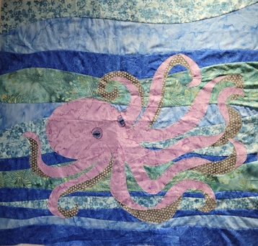
We have come up with a wavy water background in blues and greens, with an underwater seascape of corals, fish, shells, jellyfish, and maybe some artistic rocks with the octopus as the focal point. See the picture above for a general idea.
Please use batiks if possible. I like Hoffman Bali Batiks, but any made-for-patchwork batiks are fine. The advantage, apart from sheer gorgeousness, is the high-thread-count fabric used to make them. It resists fraying and doesn’t stretch out of shape quite as much. Also, all these batiks use the same range of dye colors, so they blend together very well. (If you simply can’t access these fabrics, or you find them too expensive, don’t worry. We want your block in the quilt anyway.) Whatever you decide to use, please make sure it’s 100% cotton!
This time a 6.5” square is your minimum size (based on some member feedback). You may make any rectangle with sides that are a multiple of 6”, plus a half inch seam allowance. (6.5” square, 6.5 x 12.5”, 12.5” square, 6.5 x 18.5”, etc.) If you make a larger block, maybe just make one.

Questions? Please contact The Quilt Team at quilt@fawcofoundation.org.
Now, Let’s get sewing!

To make the wavy background:
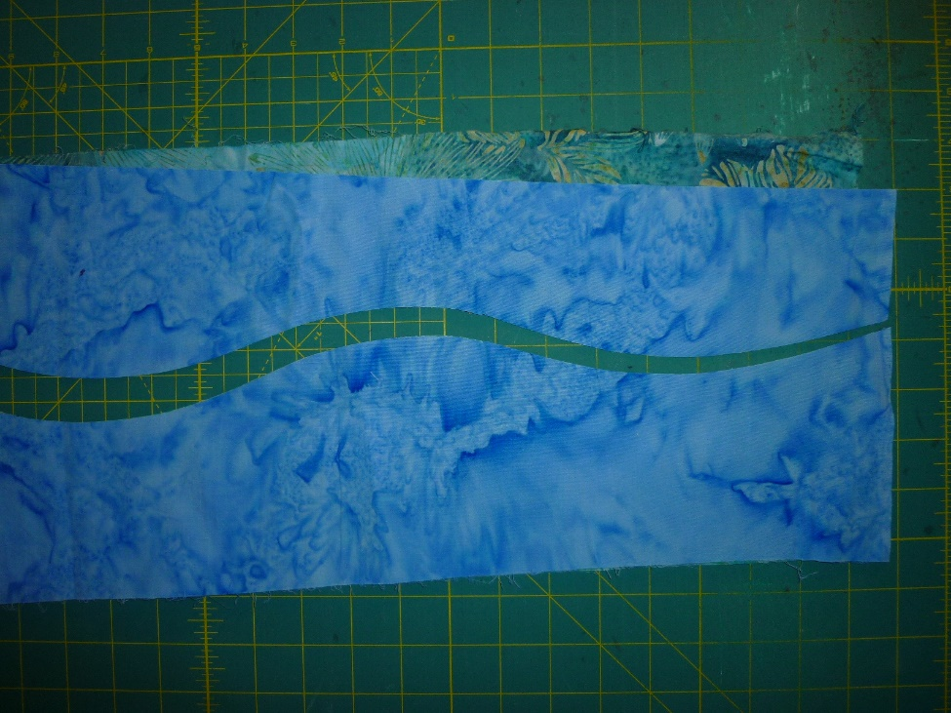
Lay 2 different strips of fabric, any width and a couple of inches longer than your desired length, one on top of the other, right sides up. With your rotary cutter, slice a smooth, wavy, shallow curve.

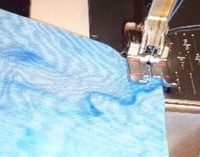
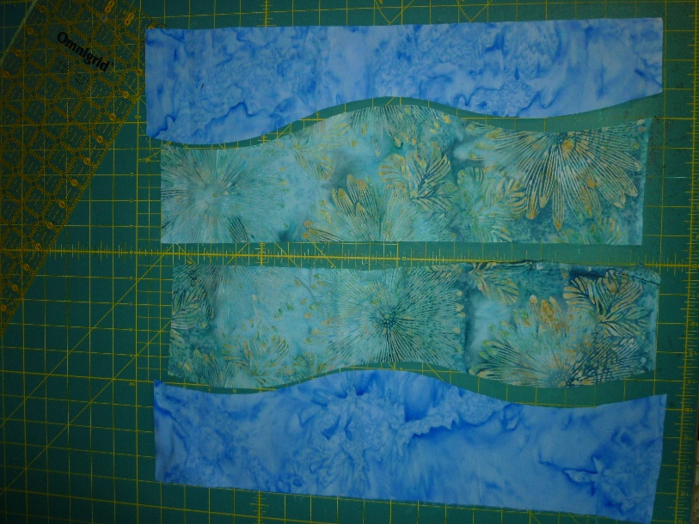
Swap the sections into 2 pairs, lay them right sides together,

and stitch them together using a narrow seam.

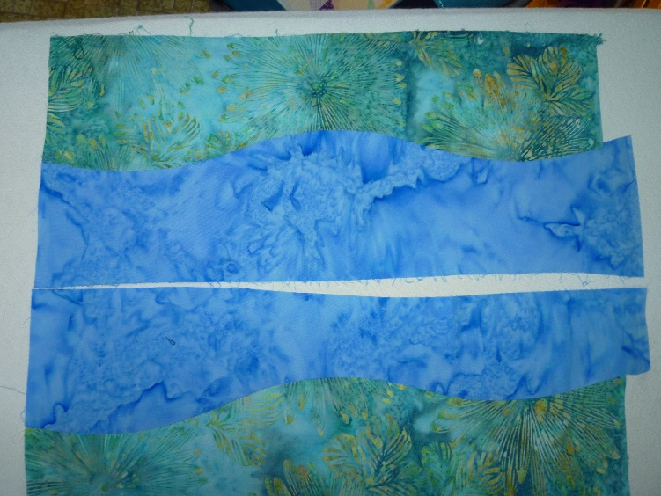

Using a very hot iron, press the seam perfectly flat, with no little tucks or pleats.

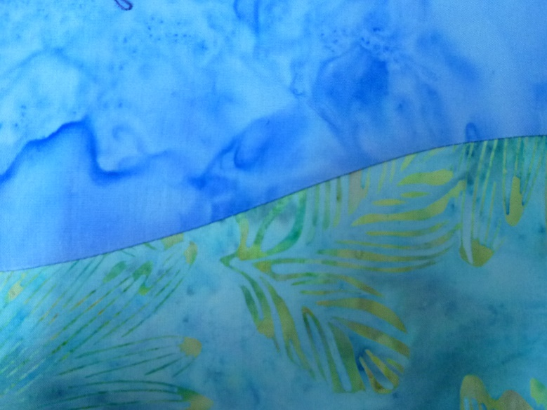

Here’s a close-up of my perfectly flat seam. Press seam allowance to one side, doesn’t matter which.

Keep adding wavy strips until your block is as wide as you want it. Note: do not try to force the edges to fit, and don’t pin it together because it will tempt you to force it where it won’t easily go. Don’t stretch it as you sew. Don’t worry if your seam allowance is not precise. Just take it slowly, keep the edges aligned, and make sure you don’t stitch in any tucks. The ends will not match, but this is why you cut it longer. (Award-winning quilter Ricky Tims calls this “caveman quilting”.)
There are many ways you can continue with your block.
- Use this piece as the background for your appliqued sea creatures.
- If applique is not your thing, of course you may make a pieced block using blue and/or green as the background. There are loads of paper-pieced designs online.
- Or feel free to embroider.
- Or if you are truly feeling overwhelmed, just send a chunk of beautiful wavy batik background to help fill in the gaps, we’re bound to need some of that too!
The very talented Lesley Klewinghaus has agreed to put this puzzle together and Roberta will pull it all together with the quilting. The deadline to submit your quilt blocks is Sunday, September 1st, 2024. No exceptions. Best to make your block(s) before the summer! That will probably suit your travel schedule too!

